|  |
| --- |
| Internship Report |
| Load Flow Analysis |
| Of Fibre Plant at RIL, Patalganga |
|  |
| **Siddharth Bhal**  **Indian Institute of Technology, Roorkee**  **En. No. 08115080**  **19th May – 4th July, 2011** |
|  |

|  |
| --- |
| Report aims at analyzing the power system at RELIANCE INDUSTRIES LIMITED, PATALGANGA. Simulation of FIBRE’s power system is done using ETAP, and same is used for Load Flow Analysis and Motor Start-up analysis. |

Table of Contents

1. Abbreviations 3

2. Preface 4

3. Reliance Industries Limited 5

4. Abstract 6

5. Introduction 7

5.1 Sources of power 7

5.2 Distribution 7

5.3Power distribution network 8

5.3.1 100 kV Receiving Substation 8

5.3.2 Captive Power Plant 9

5.3.3 PTA Complex 11

5.3.4 LAB Complex 11

5.3.5 Fibre Complex 12

6. Active & Reactive Power Control 14

6.1 Active Power Control 15

6.1.1 Single generator operation 15

6.1.2 Two or more generators running parallel 15

6.1.3 One or more generators running parallel with a grid 16

6.1.4 Active Power Control in Gas Turbine Generator 17

6.2 Reactive Power Control 18

7. Load Flow Analysis 20

7.1 Assumptions and Guidelines 20

7.1.1 Assumptions 20

7.1.2Guidelines 20

7.2 Brief Description 21

7.3 Load Flow Under Schema 1 22

7.4 Load Flow Under Schema 2 23

7.5 Load Flow Under Schema 3 30

7.6 Load Flow Under Schema 4 30

7.7 Load Flow Under Schema 5 30

7.8 Optimal Load Flow Under Schema 1 31

7.9 Optimal Load Flow Under Schema 2 31

8. Motor Startup Analyisis 31

9. Internship Activities 34

10. Conclusions 35

11. References 36

12. Conclusions 35

# Abbreviations

RIL Reliance industries Limited.

MSEB Maharashtra State Electricity Board.

GTG Gas Turbine Generator.

STG Steam Turbine generator.

DG Diesel Generator.

HRSG Heat Recovery Steam Generators.

ENC Energy Centre.

KV Kilo Volts.

PCC Power Control Centre.

MCC Motor Control Centre.

CB Circuit Breaker.

PMCC Power and Motor Control Centre.

MLDB Main Lighting Distribution Board.

PTA Pure Terapthalic acid.

LAB Liquid Alkyl benzene.

PX Paraxylene.

PSF Polyster Stable Fibre.

PFY Polyster Filament Yarn.

FDY Fully Drawn Yarn.

s/s Sub-station.

MEG Mono ethylene Glycol.

# Preface

The purpose of this report is to explain what I did and learned during my internship period with the Reliance Industries Limited (RIL), Patalganga Manufacturing Division. The report is also a requirement for the partial fulfillment of the Reliance Industries Limited (RIL) internship program. The report focuses primarily on the assignments handled, working environment, successes and short comings that I encounter when handling various tasks assigned to me by my supervisor i.e Mr. KN Rao.

Because the various parts of the report reflect my successes, observations and comments, it would be imperative that the recommendations are also given. Therefore the report contains my observations with their effect on me. It is hoped that this report would serve as a cardinal vehicle to the improvement of the internship program.

Though this report mainly focuses on the load flow study conducted by me on the power system of RIL, patalganga but also covers the power system analysis and overview. It can help you learn and understand the implementation of vertical integration adopted by RIL for the mother plant of Platalganga.

# Reliance Industries Limited

The Reliance Group is India's largest private sector enterprise, with businesses in the energy and materials value chain. Group's annual revenues are in excess of US$ 44 billion. The flagship company, Reliance Industries Limited, is a Fortune Global 500 company and is the largest private sector company in India.

Backward vertical integration has been the cornerstone of the evolution and growth of Reliance. Starting with textiles in the late seventies, Reliance pursued a strategy of backward vertical integration - in polyester, fibre intermediates, plastics, petrochemicals, petroleum refining and oil and gas exploration and production - to be fully integrated along the materials and energy value chain.

The Group's activities span exploration and production of oil and gas, petroleum refining and marketing, petrochemicals (polyester, fibre intermediates, plastics and chemicals), textiles, retail and special economic zones. Reliance enjoys global leadership in its businesses, being the largest polyester yarn and fibre producer in the world and among the top five to ten producers in the world in major petrochemical products.

Patalganga Manufacturing Division located near Mumbai comprises of polyester, fibre intermediates and linear alklyl benzene manufacturing plants.

|  |  |
| --- | --- |
| Products manufactured | Raw materials |
| Para Xylene (Px) | Naphtha |
| Purified Terephthalic Acid (PTA) | Para Xylene |
| Polyester Filament Yarn (PFY) | PTA & MEG |
| Polyester Staple Fibre (PSF) | PTA & MEG |
| Linear Alkyl Benzene (LAB) | Kerosene & paraffin |

|  |  |
| --- | --- |
| Name of Plant | Commissioned Year |
| Polyester Filament Yarn (PFY) | Oct.1982 |
| Polyester Staple Fiber (PSF) | Mar.1986 |
| Purified Terephthalic Acid (PTA) | Feb.1988 |
| Paraxylene Plant (PX) | Nov.1988 |
| Linear Alkyl Benzene Plant (LAB) | Nov. 1987 |
| L A B (Front End) | Mar.1992 |

# Abstract

This report mainly focuses on:

* Conceptualization and analysis of various hookup schemes with merits and demerits of system operation and selection of optimum scheme for implementation.
* Conducting load flow studies for various exigencies of operation for deciding the operational philosophy.
* Finding out the voltage availability at various voltage levels during a given fault condition.
* Studying the behaviors of the system under large motor starting condition to ensure that motors can be started successfully direct on line without any disturbance to rest of the system.
* See the impact of HT motors starting on the power system and thus finding the alternatives in case of high voltage dip on respective buses/ motor terminals.
* To study the transient analysis of the power system and simulate different operating conditions and thus study them.

# Introduction

## Sources of power

MSEB Contractual demand of 15 MVA  
GTG 2 x 30 MW  
STG 1 x 24 MW  
DG 2 x 4.1 MW + 2 x 2.5 MW

## Distribution

MSEB power is received at 100 KV level.

RIL - PG Complex is divided in three load centres, viz. PTA Complex, Fibre Complex and LAB Complex. Power is distributed at 22 KV level to each of these complexes. Other voltage levels used are 11 KV, 6.6 KV and 433 Volts.

11 KV level is used for distribution in PTA complex fed to various step-down transformers and one HT Motor.

6.6 KV level is used for 6.6 KV HT Motor supply and 6.6 kV distribution.

433 V level is used for LT Motors.

From 433 V side of transformer, power is fed to PCC / PMCC. From PCC, there are outgoing feeders to MCC. Individual motor receives power from MCC through motor feeder.

For critical loads, UPS systems are used for critical loads like DCS, motor control, boiler auxiliaries and instrument controls.

For breaker controls and some motors, DC supply is used, which is available from DC power supplies.

## Power distribution network

### 100 kV Receiving Substation

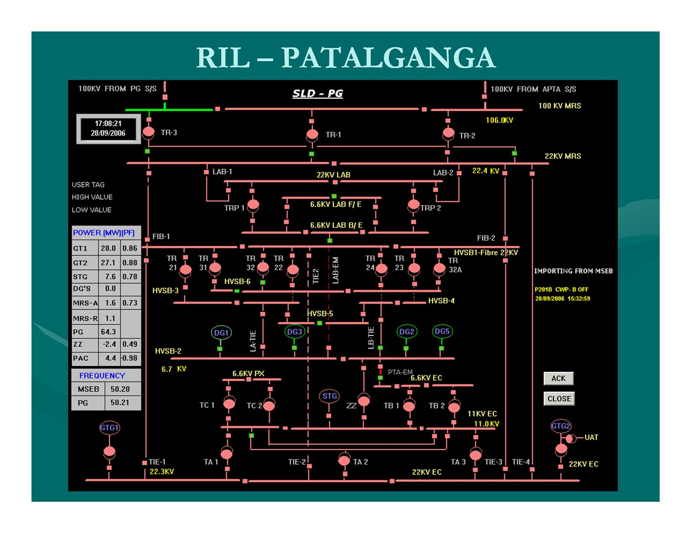RIL, PG complex receives MSEB power through 2 Nos. 100 kV overhead lines, coming from Apta and Patalganga s/s at our 100 kV main receiving station.

Fig 5.1

Depending upon the load requirement of the consumer, MSEB decides the supply voltage.

Advantages of going for High Voltage Level are:

1. Less possibility of line faults.
2. High reliability.

This 100 kV voltage is stepped down through 3 nos. 100 / 22 kV, 32/40 MVA transformers. Theses transformers are connected to the 22 kV switchboard at 100 kV substation. From this switch board, 2 feeders each are taken to 22 kV switch boards at LAB complex and Fibre Complex.

Also, there is one tie feeder between the 22 kV switch board at 100 kV s/s and 22 kV switch board at ENC in PTA complex.

### Captive Power Plant

The captive power plant is situated at Energy Centre in PTA complex. It consists of 2 nos. 30 MW GTG with HRSG and a 24 MW STG. There are 3 nos. 70 tonnes / hr each boilers which along with 2 nos. Horses, supply steam for power generation and process plants.

GTG 1 and GTG 2 are connected to 22 kV switch board section A and C respectively at Energy Centre through 11/22 kV, 53 MVA step-up generator - transformers.

There are 3 nos., 22/11 kV, 15 MVA transformers TA-1,2,3 which connect the 22 kV switch board to the 11 kV switch board where STG is connected.

#### Also, there are 3 nos., tie feeders between 22 kV switch board at Energy Centre and 22 kV switch board at Utility substation. Thus power is fed from CPP to Fibre complex. There is an interconnection between 11 kV bus at Energy Centre and 6.6 kV bus at Utility s/s through 15 MVA Zig-Zag transformer which connects STG & DG to fulfill normal power requirement at HVSB # 2 bus.

#### PTA Plant

HT motors (4 nos., 6.6 KV & one 11kV) in PTA Plant receive power from Energy Centre.

LT loads at PTA receive power through 7 nos., 2 MVA, 11 KV / 433V transformers TE2, TE3, TE4, TF1, TF2, TF3 and TK1 connected to PCC-E, PCC-F and PMCC-K.

Transformer TE1 (2 MVA, 6.6 kV / 433 V) fed from 6.6 KV switchboard - B at ENC fulfills emergency power requirement at PTA.

There are 110V and 50 V DC chargers with battery backup. Also 110V AC UPS system for critical power supply is provided.

#### Energy Centre

All loads of Energy Centre are connected to 11 kV bus.

6.6 kV switch board - B at Energy Centre receives power from 2 nos., 10 MVA, 11 kV / 6.9 kV transformers TB1 & TB2. On this switch board various HT drives of Energy Centre (13 nos.) & PTA plant are connected (4 nos.).

On this 6.6 kV switch board - B, feeder from DG bus at Utility is connected as a source of emergency power. In case of total power failure, critical drives and lighting get this power. Transformers TD1 ( 2 MVA, 6.6 kV / 433 V) supplies this emergency power to various critical loads of Energy Centre through PCC - D.

For LT distribution at Energy Centre - Boiler House, there are 2 nos., 11 kV / 433 V, 2 MVA transformers, TD2 & TD3. LT side of these transformers connected to PCC-D which further feeds MCC 11, 12, 13 and 14 feeding to various loads of boilers and STG auxiliaries. Also transformers TD4 and UAT supply auxiliaries of GTG 1 and GTG 2 respectively.

For LT distribution at Energy Centre - Offsites, transformers TJ1, TJ2 and TJ3 (11 kV / 433 V, 2 MVA) feed PCC-J. From this PCC, MCC UT 1 through UT 7 are fed. These give power to Demineral Water Plant, Compressor house, Effluent treatment plant, Water treatment plant, Cooling water plant, Chilled water plant etc.

For DC distribution, there are 125V, 110V and 50V chargers with battery back-up. 125 / 110 DC is used for electrical breaker control and DC motors. 50 V DC is used for instrument controls.

For DCS and other critical control supplies, there are 3 nos. UPS systems. (For GTG2 and Boiler / STG UPS - output voltage is 110 AC. For GTG1 output voltage is 3, 415V AC stepped down to 110VAC for distribution.)

### PTA Complex

PTA complex consists of PTA plant, PX plant and Energy Centre. These plants get power from Energy Centre 11 kV Bus.

Voltage is stepped down by 11 / 6.9 kV, 6.6kV / 433 V & 11kV / 433 V transformers for use in HT & LT drives and other loads.

#### PX Plant

There is a 6.6 kV, 350 MVA switch board - C at PX plant, which gets power from 11 kV Energy Centre switch board through 2 nos., 11 / 6.9 kV, 10 MVA transformers TC1 & TC2. Various HT drives (13 nos.) are connected on this switch board.

For LT distribution, there are 6 nos; 2 MVA, 11 KV / 433 V transformers namely TG1, TG2, TG3, TH1, TH2 & TH3 connected to PCC G and PCC H. Transformer TH4, (6.6 KV/ 433 V, 2 MVA) fed from 6.6 KV switchboard -B at ENC supplies emergency power for PX plant.

There is 110V DC charger with battery backup for DC distribution. For critical loads such as DCS, 110V ac UPS system is provided.

### LAB Complex

LAB complex consists of Front End, Back End, A3, B1, B2 & B3 tank farms.

LAB Complex receives power at 22 kV level through 2 Nos. 22 kV feeders from 100 kV substation. This is stepped down through 2 nos., 22 / 6.9 kV, 15 MVA, Zig-Zag transformers TRP 1 & 2 and connected to 6.6 kV, 350 MVA switch board LAB - back end which is divided in three sections. From this switchboard there are 9 nos., 6.6 kV motor feeders.

From 6.6 kV switchboard LAB back end, there are 2 feeders to 6.6kV switchboard LAB-front end. There are 18 nos., 6.6 kV motor feeders from this switchboard.

A-3 tank farm, which comes under LAB plant, receives power from PSF plant.

### Fibre Complex

Fibre Complex consists of Utilities, PFY - I, FDY, PSF & PFY - II plants.

#### Utilities Plant

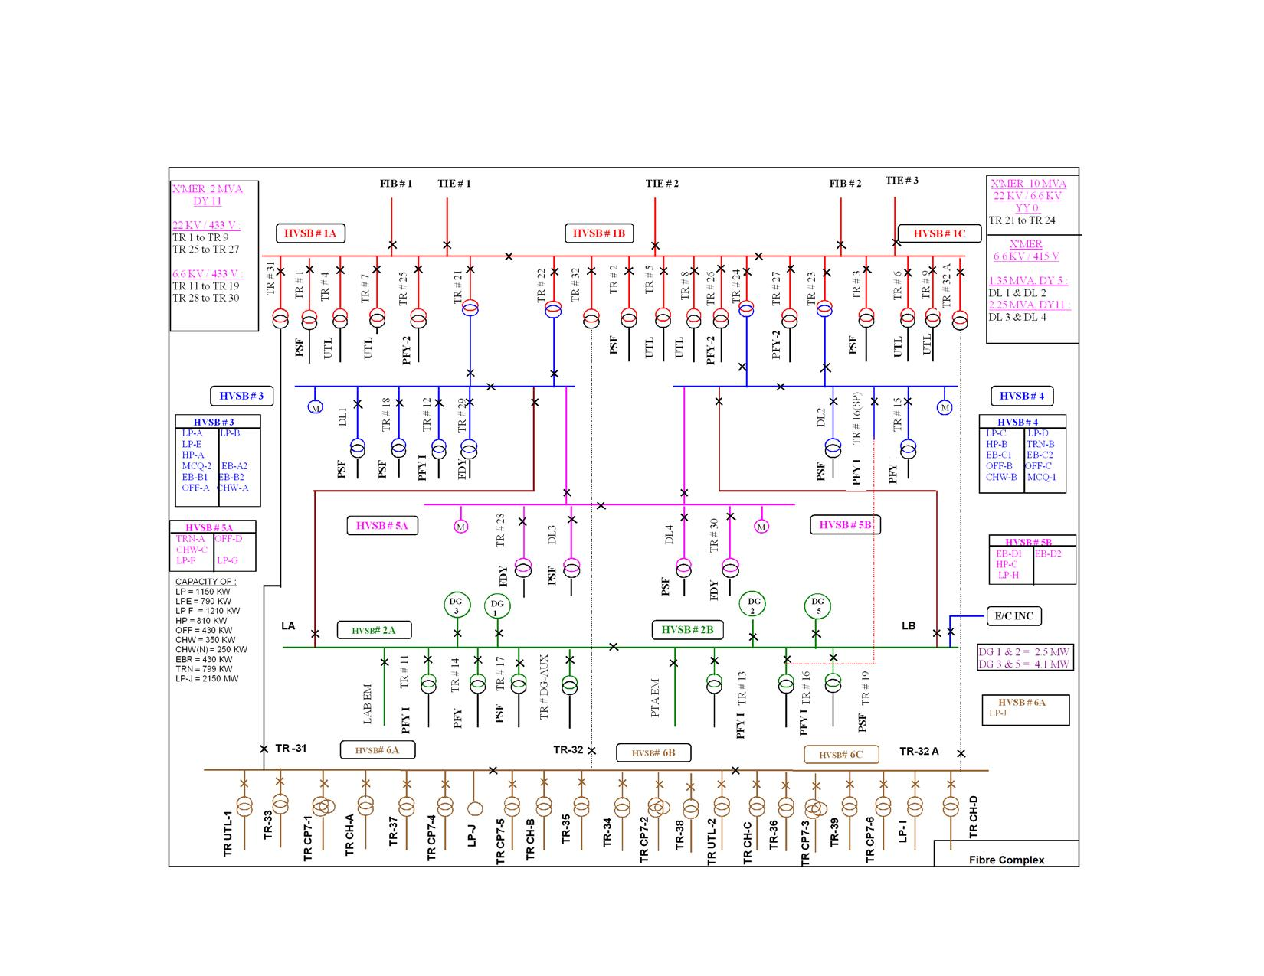Fibre complex receives power from 22 kV switch board at 100 kV s/s through 2 nos. 22 kV feeders connected to 22 kV switch board namely HVSB # 1 at the Fig 5.2

utilities substation. This switch board is also connected to Energy Centre 22 kV switch board by 3 nos. tie feeders through which the CPP power is available to Fibre complex. From the 22 kV switch board HVSB # 1 there are feeders to 4 nos., 22 / 6.6 kV, 10 MVA transformers TR 21 - TR 24 which feed power to 6.6 kV switch boards namely HVSB # 3 and HVSB # 4. HVSB # 5 receives power from both HVSB # 3 and HVSB # 4.

From HVSB # 3, 4, 5 various HT motors (29 nos.) at Utilities are fed. Also there are 10 nos., 6.6 kV / 433 V, 2 MVA transformer feeders which feed LT loads in PFY, PSF and FDY plants.

There are 4 nos DG sets (2 x 2.5 MW - DG 1 & 2, 2 x 4.1 MW - DG 3 & 5 ) connected to 6.6 kV switch board HVSB # 2. From 6.6 kV switch board HVSB # 2, there are 6 nos., 6.6 kV / 433 V, 2 MVA transformer feeders for PSF and PFY-1 plants.

There are feeders to PTA complex (6.6 kV switch board- B at Energy Centre) and LAB complex (6.6 kV switch board at LAB) so that DG power is available to the critical drives in case of total power failure.

Also, there is one small, 430 V, 315 kVA, lighting DG in utilities substation which supplies critical lighting load in Fibre Complex in case of complete power failure in Patalganga complex.

From 22 kV switch board, HVSB # 1 there are feeders to 12 nos., 22 kV / 433 V, 2 MVA transformers which supply power to LT loads in PSF, PFY - I, PFY - II, FDY, and Utilities plants.

#### PSF Plant

PSF Plant gets power from HVSB#1 through transformers TR 1, 2 and 3 which are connected to PCC# 1 - 3. This PCC supplies power to Draw machines 1 - 4, balers 1 - 4, MCC 103 & 104 and non critical loads of CP4, CP5 & spinning. Also, one feeder goes to A3 tank farm.

Critical loads of CP4, CP5, UPS., MCC 21 - 24 are fed from PCC # 17 - 19 which receives power from TR17, 18 & 19 (TR 17 & 19 supplied from HVSB#2 and TR18 from HVSB#3.)

Transformers DL1 (fed from HVSB # 3) and DL 2 (fed from HVSB # 4) supply power to PCC-DL1 and PCC-DL2 respectively. These PCCs supply power to DC drives of DM 1-4.

Transformers DL3 and DL4 are fed from HVSB # 5 and are connected to PCC # DL3 - 4. This PCC feeds power to Draw machines - 5 and Baler - 5.

#### PFY I Plant

This plant receives power from 6.6 KV switchboard HVSB # 2 (TR 11, 13, 14, 16), HVSB # 3 (TR 12) and HVSB # 4 [(TR 15 and TR 16 (Spare)].

Transformers TR 11, 12 and 13 supply power to PCC # 11-13. Transformers TR 14, 15 & 16 supply power to PCC # 14 - 16.

PCC # 11 - 13 supplies power to both MPP 1 (CP 1) and MPP 2 (CP 2 and CP 3). PCC # 14 - 16 supplies power only to MPP 2.

From PCCs, power is fed to DC drives, DCPS and UPS.

#### FDY Plant

FDY Plant gets power from HVSB#5 through 3 nos., 2 MVA, 6.6 KV / 433 V transformers TR 28, 29 and 30. They supply power to PCC # 28-30.

From this PCC, there are feeders to MCC 1A, 1B, 2, 3, common MCC A, common MCC B, and Emergency DB. These MCCs supply power to various UPS, DCPS, Inverters and heaters.

#### PFY II Plant

PFY II receives power from HVSB # 1 through transformers TR 25, 26 and 27. These are connected to PCC # 25 - 27. All spinning machines and MCC 101, 102 are supplied from PCC # 25 - 27.

# Active & Reactive Power Control

In a Power System, there are various types of load such as:

a) Motors

b) Heating and lighting loads

c) Electronic devices

## Active Power Control

Active power is a direct function of the fuel input to the drive of the generator, which may be a turbine or engine. For increasing / decreasing the active power output of a generator, the fuel input to the prime mover has to be increased / decreased.

The control of fuel input is either manual or automatic.

There are different conditions of operation of generators,

1. Only one generator running in isolation,
2. Two or more generators running parallel (in isolation with the grid),
3. One or more generators running in parallel with grid.

### Single generator operation

The load on the generator governs the active power output of the generator. Whenever the load changes, the frequency changes for the same input to the prime mover. This is because output is more at reduced rpm and vice versa. To maintain operating frequency, the input fuel is varied. This may be done manually. But this will require continuous watch on frequency. Hence, automatic frequency control is provided which monitors the frequency continuously and whenever its value goes beyond prefixed band, a signal is given to governor to change the fuel input to the drive. This mode of operation is called as "Isochronous" Mode.

### Two or more generators running parallel (in isolation with the grid)

#### Master - Follower Scheme

When there are more than one generator running parallel in a network, but in isolation with the grid, the Master - Follower scheme is used. One generator acts as Master and others "Follow" it. Whenever the load changes, the frequency changes accordingly. This change is sensed by the Master generator first and the additional load is distributed to follower units in proportion to their capacities.

Advantages of Master-Follower scheme:

1. Single point control of active power.

2. Increase in load is distributed in proportion to the capacity of individual generators.

Disadvantages of Master-Follower scheme:

1. In case of fuel starvation to Master generator, its generation decreases and bus frequency also decreases. Cascade effect of the above is that entire bus may collapse. Hence, the master follower scheme won't be active below a specified generation level of master generator. The operator shall, in such case, change the selection to other generator as "Master".

#### Droop mode

There is another method of operation in which the changes in load will be shared by the generators running in parallel as per their governor characteristics. If their capacities and characteristics are exactly matching, the additional load will be equally shared.

### One or more generators running parallel with a grid

When one or more generators are running parallel with grid, they follow grid voltage and frequency. This is due to very high inertia of the grid as large number of generators is connected in the grid. Hence it is called as ' Infinite Bus ', having little or no effect on its voltage and frequency with changes in excitation and mechanical input to the generators in Captive Power Plant.

Hence, a change in excitation of generator connected to grid shall result in change in its reactive power. A change in mechanical input (fuel) shall result in change in its power output (MW).

### Active Power Control in Gas Turbine Generator

Various modes of operation in GTG are described below:

1. Preselect mode: Selection of this mode is normally resorted to when we are operating in parallel with the grid. The machine load will be at a preselect value irrespective of any changes in the grid frequency. The magnitude of power which can be selected is within the machine capability. Any external load control signal (command to increase or decrease the speed) will bring out the machine from the preselect mode of operation and takes it into "droop mode". In this mode of operation, machine follows grid frequency. But if frequency decreases or increases, the generator tries to follow it and accordingly active power output increases or decreases. Hence it is advisable to select the machine to preselect mode.
2. Base load mode: This is the most economical mode of operation when HRSG is also in operation. This is basically a temperature control. The machine will be loaded to its maximum capability within its permissible temperature of exhaust gases. The output of the machine goes on varying as per the changes in the ambient temperature.
3. Peak load mode: This is also a temperature control mode of operation similar to base load but the exhaust gas temperature set value will be at a higher value. This is not a regularly recommended mode of operation as it will be overstressing the machine.
4. Droop mode: This is the mode of operation when machine is running in parallel with the grid. The increase and decrease in grid frequency will decrease or increase the generation of the machine. Similarly, in isolation, if the load increases, the frequency falls and vice-versa. Here also, the load which the machine can take is limited to base load capacity.
5. Isochronous mode: Selection of this mode is normally resorted to when the machine is operating in isolation with the grid. This is basically a constant speed control which keeps the machine operating frequency at preset value.

Normal mode of operation when operating in parallel is preselect mode at a specified generation.

When islanded from the grid due to any grid abnormalities, islanding signal is given which will bring the generator out of the preselect mode to droop mode. After the machine is in droop control mode, it may manually be taken to isochronous mode.

## Reactive Power Control

Major part of the industrial loads is the motor load (nearly 95%). In industry, squirrel cage induction motors are largely used. This inductive load requires a large amount of reactive power depending on the rated power factor of the individual motor.

Inductive load is treated as sink of reactive power and capacitive load is treated as source of reactive power.

Large reactive power means larger complex power hence the higher rating of machines. Also large reactive power means higher line current hence higher losses. Also the generator terminal voltage sags if the reactive power requirement is higher and non-compensated by appropriate increased in generator excitation. Hence, State Electricity Boards impose penalty on lower power factors. This is because for the same amount of active or useful power required by the industry; the rating of transformers, transmission line and generators needs to be on the higher side. Also, the loss in transmission and distribution is more as the line current is higher with lower power factor.

Sources of leading reactive power are:

1. Power factor improvement capacitors,
2. Synchronous motors running on over excitation mode,
3. Generator running on over excitation mode,
4. Synchronous condensers.

Reactive power control is done in two stages. Primarily, the capacitor banks are installed at various load centres to compensate the lagging reactive power requirement at that load centre. This improves the power factor at that load centre and reduces the line losses.

The balance reactive power requirement is met with either from grid or generated by captive generators. To maintain grid power factor above 0.9, the reactive power of captive generators is controlled. This is second stage of reactive power control.

Power drawn from MSEB at a power factor less than 0.9 imposes penalty. Thus, in order to fulfill this requirement, power factor improvement of the system is necessary.

When the captive power plant is running in isolation, the reactive power requirement of the load has to be fulfilled by generators themselves. Production of active and reactive power of a generator is guided by its capability curve. Exceeding the limits of the capability curve will lead to temperature rise of the machine beyond acceptable limits. Hence, the additional reactive power requirement is catered by installation of capacitor banks.

When captive generators are running in parallel with grid, reactive power is controlled by increasing or decreasing the excitation current of the machines. This is done with the help of AVR. Increase in generator VAR output leads to poor power factor of the machine and vice-versa. The total VAR requirement of the system is met by the generators, installed capacitors and the balance requirement is met by the grid.

# Load Flow Analysis

## Assumptions and Guidelines

### Assumptions

* MSEB Grid, 100 KV sub-station fault level is taken to be 8888 MVA.
* Generation output is assumed as follows:  
  STG: 8MW  
  GTG-1,2: 27MW
* For motors starting power factors, starting current to full load current ratio and efficiency are assumed in cases where they aren’t supplied.
* Load of transformers are considered to be lumped and a power factor of 0.85 is assumed i.e all PCC’s and MCC’s connected to secondary of transformer are considered as lumped load.
* Lumped loads are considered to be 80% constant KVA loads (motors) and 20% constant impedence loads (static loads).
* Various time-constants for motor LLP-J, Generators GTG-1, GTG-2 & STG, in motor startup analysis are assumed as per prevailing standards of equipment in that capacity range.
* Complete ENC load (19.6 MW) is considered to be equally divided on three buses of 11kv ENC.
* Cables lengths are approximately assumed and their parameters are taken from the standards prevailing in industry according to their area of cross-section and make.

### Guidelines

* Normal voltage levels are taken to be 95% to 105% for system operation.
* Capacitor banks at the bus shall be used to minimize the reactive power import from grid instead of the synchronous motor running at leading power factor, since only fibre and ENC loads are considered in load flow.
* The existing diesel generating sets aren’t considered for this study.
* Many standby transformers are present in the power system which aren’t loaded under normal circumstances. These have been neglected in the study.
* Unit Auxillary transformer for GTG-2 isn’t considered.

## Brief Description

The existing electrical system at Patalganga consists of 2 nos GTG of 34 MW and 1 no STG of 25 MW capacity. Back-up power to complex is planned through MSEB Grid through 2 nos 100 KV overhead lines coming from MSEB Apta and Patalganga sub-station. The MSEB power is stepped down from 100 KV to 22 KV at RIL 100 KV switchyard through 3 nos 100/22 KV 40 MVA transformers (TR-1,2,3). These transformers are connected to 22 KV switchboard at 100 KV switchyard. From this 22 KV switchboard, 2 nos feeders each are taken to PTA complex (E/C), FIBRE complex (utility s/s) and LAB complex. In-plant generators are installed at E/C.

GTG feed power to 22 KV switchgear through 11/22 KV, 53 MVA generator transformers. Further 22 KV voltage level at E/C is stepped down to 11 KV through 3 nos 22/11 KV, 15 MVA transformers (TA-1,2,3) and are connected to bus sections 1 & 3 of 11 KV switchgear at E/C. 25 MW STG is connected to middle bus section of this 11 KV switchgear directly.

In-plant generators operate in parallel with MSEB through its tie feeders between 22 KV switchyard and energy center boards.

The FIBRE complex receive power from 22 KV switchboard located in 100 KV switchyard. 2 nos feeders (FIB-1,2) are provided to feed power to two bus sections of 22 KV FIBRE switchboard. This power is further stepped down to 6.6 KV and from 6.6 KV to 415 V to feed power to FIBRE complex and utility loads.

FIBRE complex also has a 6.6 KV emergency switchboard which receives power from 2 x 2.5 MW + 2 x  4.1 MW DG sets. In addition energy board also receives power directly from energy center 11 KV switchboard through 1 no 15 MVA, 11/6.6 KV Zig-Zag transformer. Normally DG sets operate in parallel with rest of the power supplies of the complex.

The Lab complex receives power from 22 KV switchboard in 100 KV switchyard by means of 2 nos feeders. The power is stepped down to 6.6 KV and from 6.6 KV to 415 V. The 6.6 KV switchgear and 415 V PCC’s feed power to LAB complex loads.

Load flow analysis for RIL, patalganga plant is carried out for determining the steady state power flow and voltage profile of the distribution system. It is assumed that MSEB grid voltage is 100%. Total plant load is ~50 MW with a captive generation of 93 MW.

## Load Flow Under Schema 1

|  |  |  |  |
| --- | --- | --- | --- |
| Schema 1 | | | |
| Fibre load: | 31.6 MW. | STG output: | 8 MW @ 79% pf |
| ENC load: | 19.6 MW | Zig-Zag Tranf. | **Off** |
| GTG1 output: | 27 MW @ 88% pf. | LA,LB: | **On** |
| GTG2 output: | 27 MW @ 84% pf | MSEB Grid | Charged |
| DG’s | Off | TA-1 | **On** |
| TA-2 | **On** | TA-3 | **On** |

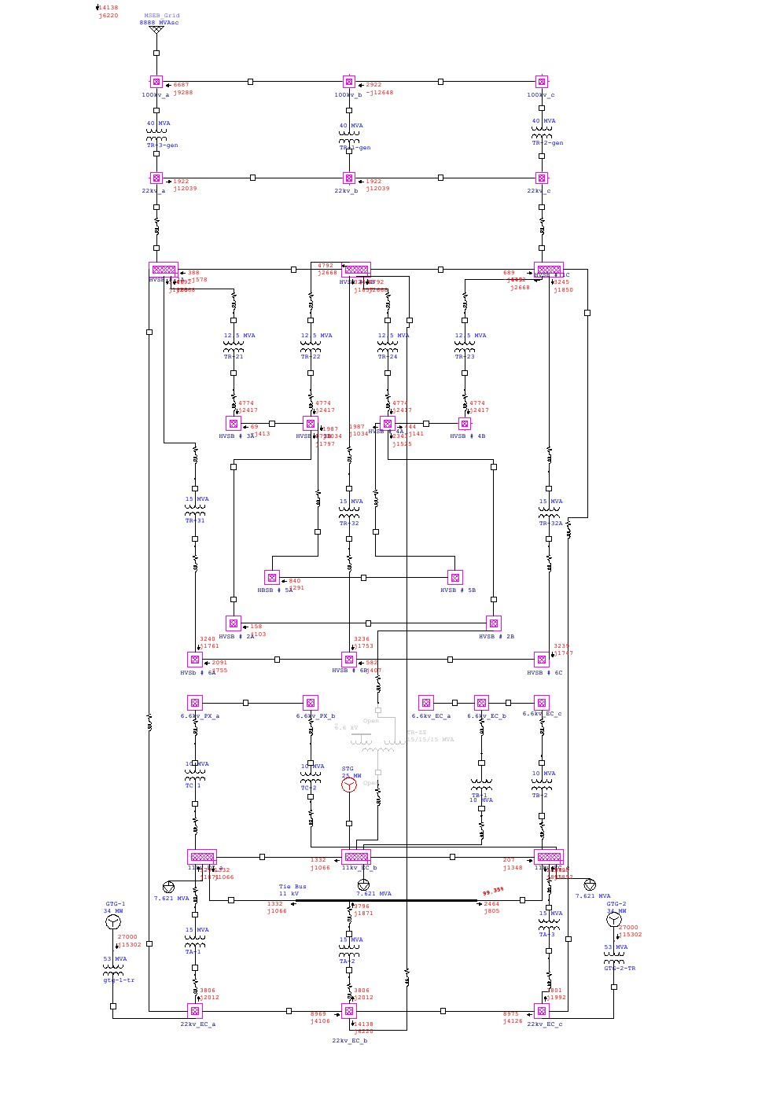

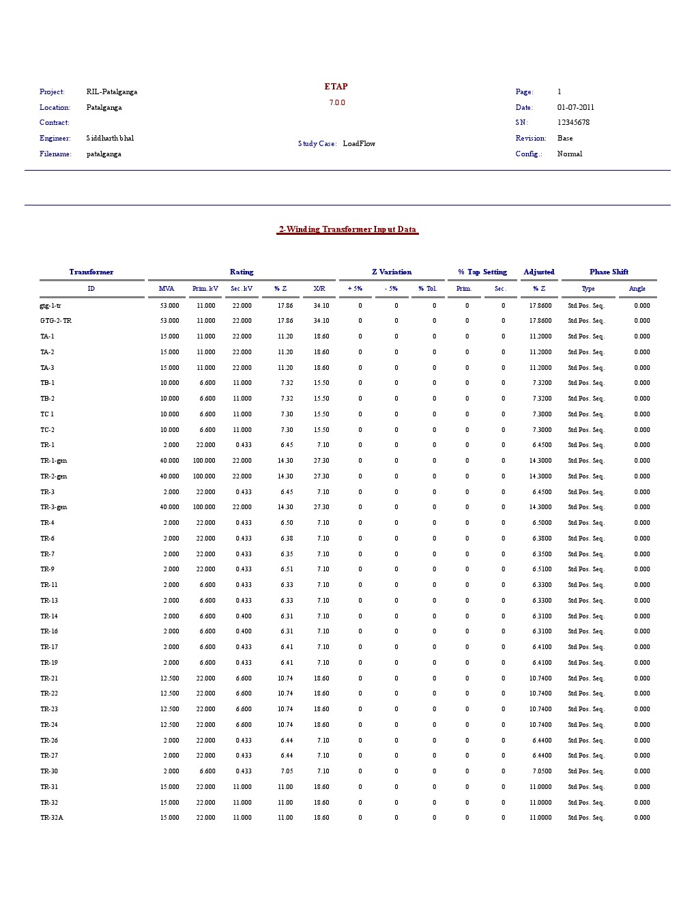

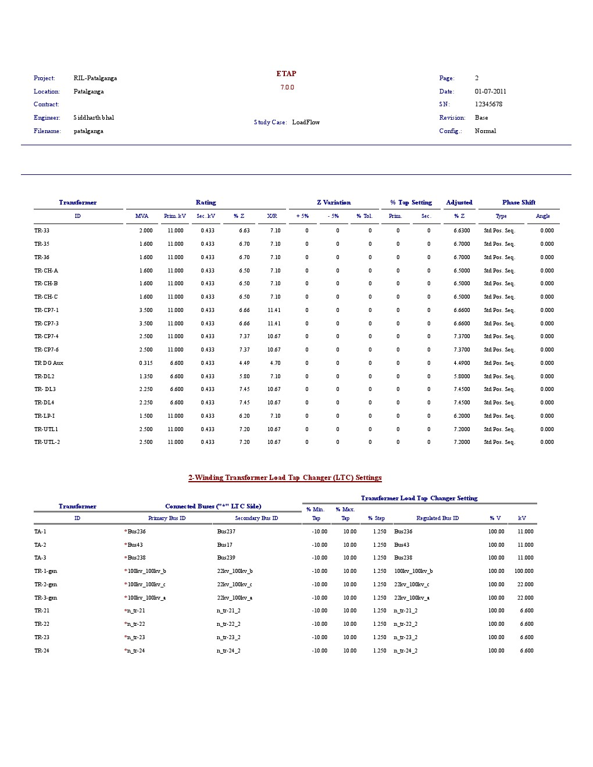

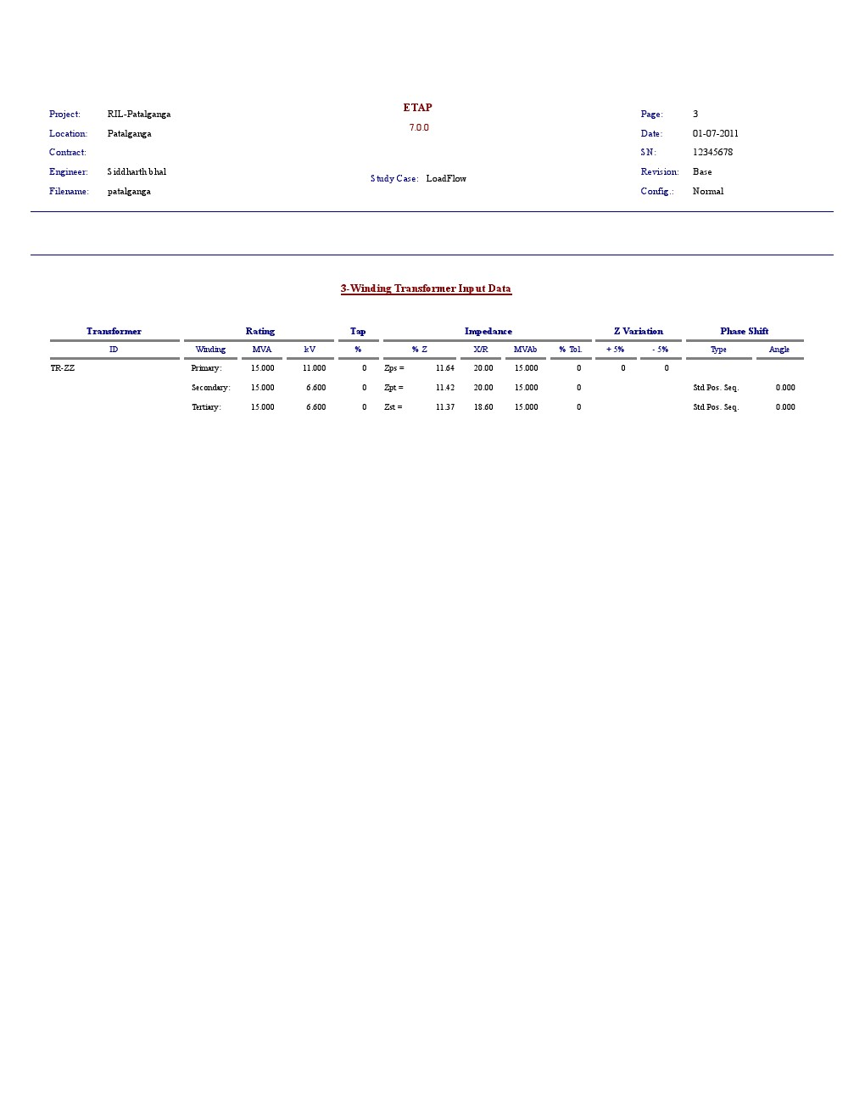

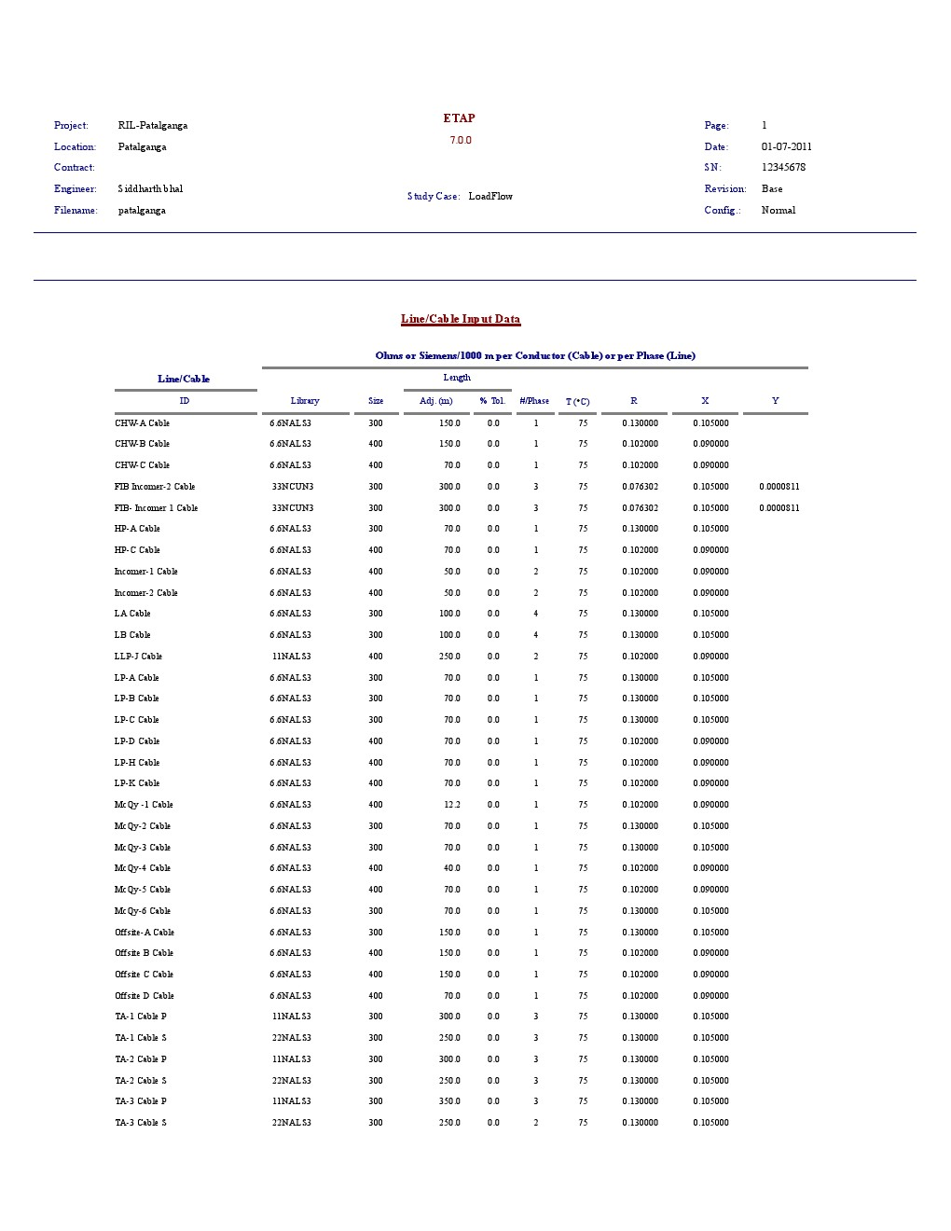

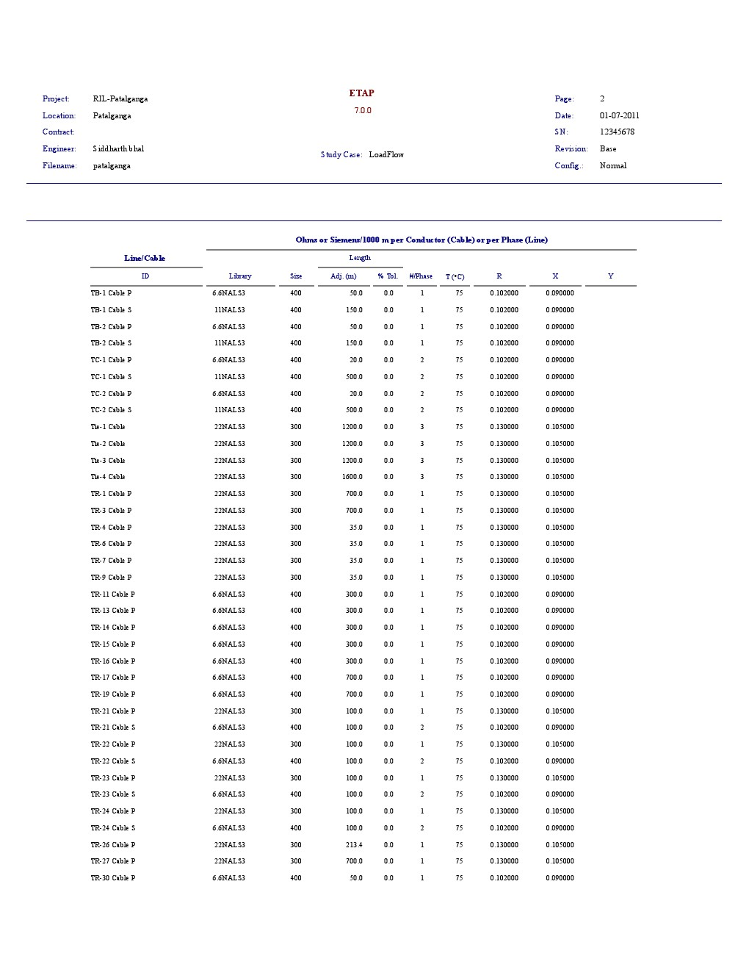

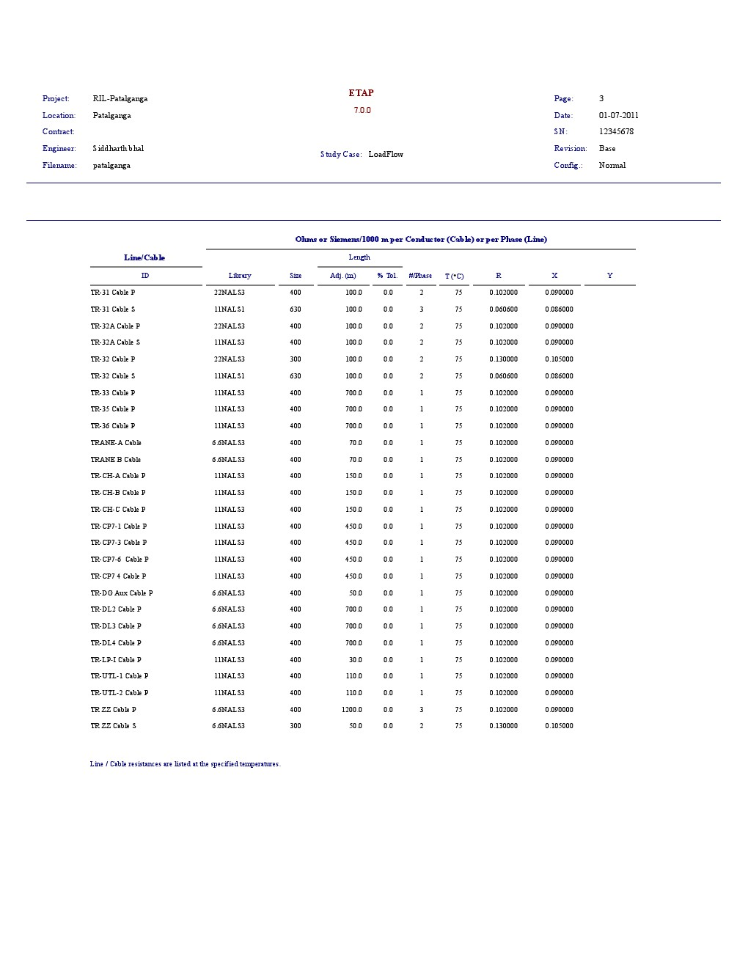

## Load Flow Under Schema 2

|  |  |  |  |
| --- | --- | --- | --- |
| Schema 2 | | | |
| Fibre load: | 31.6 MW. | STG output: | 8 MW @ 79% pf |
| ENC load: | 19.6 MW | Zig-Zag Tranf. | **On** |
| GTG1 output: | 27 MW @ 88% pf. | LA,LB: | **On** |
| GTG2 output: | 27 MW @ 84% pf | MSEB Grid | Charged |
| DG’s | Off | TA-1 | **On** |
| TA-2 | **On** | TA-3 | **Off** |

Reports are attached in Appendix B.

## Load Flow Under Schema 3

|  |  |  |  |
| --- | --- | --- | --- |
| Schema 3 | | | |
| Fibre load: | 31.6 MW. | STG output: | 8 MW @ 79% pf |
| ENC load: | 19.6 MW | Zig-Zag Tranf. | **On** |
| GTG1 output: | 27 MW @ 88% pf. | LA,LB: | **On** |
| GTG2 output: | 27 MW @ 84% pf | MSEB Grid | Charged |
| DG’s | Off | TA-1 | **On** |
| TA-2 | **Off** | TA-3 | **Off** |

Reports are attached in Appendix B.

## Load Flow Under Schema 4

|  |  |  |  |
| --- | --- | --- | --- |
| Schema 4 | | | |
| Fibre load: | 31.6 MW. | STG output: | 8 MW @ 79% pf |
| ENC load: | 19.6 MW | Zig-Zag Tranf. | **On** |
| GTG1 output: | 27 MW @ 88% pf. | LB | **Off** |
| GTG2 output: | 27 MW @ 84% pf | MSEB Grid | Charged |
| DG’s | Off | TA-1 | **On** |
| TA-2 | **Off** | TA-3 | **Off** |

## Load Flow Under Schema 5

|  |  |  |  |
| --- | --- | --- | --- |
| Schema 5 | | | |
| Fibre load: | 31.6 MW. | STG output: | 8 MW @ 79% pf |
| ENC load: | 19.6 MW | Zig-Zag Tranf. | **On** |
| GTG1 output: | 27 MW @ 88% pf. | LA,LB: | **Off** |
| GTG2 output: | 27 MW @ 84% pf | MSEB Grid | Charged |
| DG’s | Off | TA-1 | **On** |
| TA-2 | **On** | TA-3 | **Off** |

## Optimal Load Flow Under Schema 1

|  |  |  |  |
| --- | --- | --- | --- |
| Schema 1 | | | |
| Fibre load: | 31.6 MW. | STG output: | 8 MW @ 79% pf |
| ENC load: | 19.6 MW | Zig-Zag Tranf. | **Off** |
| GTG1 output: | 27 MW @ 88% pf. | LA,LB: | **On** |
| GTG2 output: | 27 MW @ 84% pf | MSEB Grid | Charged |
| DG’s | Off | TA-1 | **On** |
| TA-2 | **On** | TA-3 | **On** |

## Optimal Load Flow Under Schema 2

|  |  |  |  |
| --- | --- | --- | --- |
| Schema 2 | | | |
| Fibre load: | 31.6 MW. | STG output: | 8 MW @ 79% pf |
| ENC load: | 19.6 MW | Zig-Zag Tranf. | **On** |
| GTG1 output: | 27 MW @ 88% pf. | LA,LB: | **On** |
| GTG2 output: | 27 MW @ 84% pf | MSEB Grid | Charged |
| DG’s | Off | TA-1 | **On** |
| TA-2 | **On** | TA-3 | **On** |

# Motor Startup Analyisis

|  |  |  |  |
| --- | --- | --- | --- |
| LLP-J Motor Specifications | | | |
| Frame size: | 8012 | Rated Output: | 2125 KW |
| Voltage Level: | 11 Kv | Service factor: | 1 |
| Operating Frequency: | 50 Hz. | Rated Speed | 2977 rpm |
| Efficiency(1/2 load) | 94.4 | Full Load Ampere | 127 amp |
| Efficiency(3/4 load) | 95.0 | Locked Rotor Ampere | 742 amp |
| Efficiency(full load) | 94.9 | No Load Ampere | 17.1 amp |
| PF (1/2 Load) | 91.5 | Full load torque | 5028 lb-ft |
| PF (3/4 Load) | 92.8 | Starting Torque | 3268 lb-ft |
| PF (Full Load) | 92.5 | Breakdown Torque | 11313 lb-ft |
| Rotor wk2 | 1244 lbs-ft2 | Motor Weight | 26700 lbs |
| Customer wk2 | 1602 lbs-ft2 | Rotor Weight | 4014 lbs |

Motor start-up performance of Low- Low pressure compressor (LLP-J) is shown through various curves between various parameters as follows:

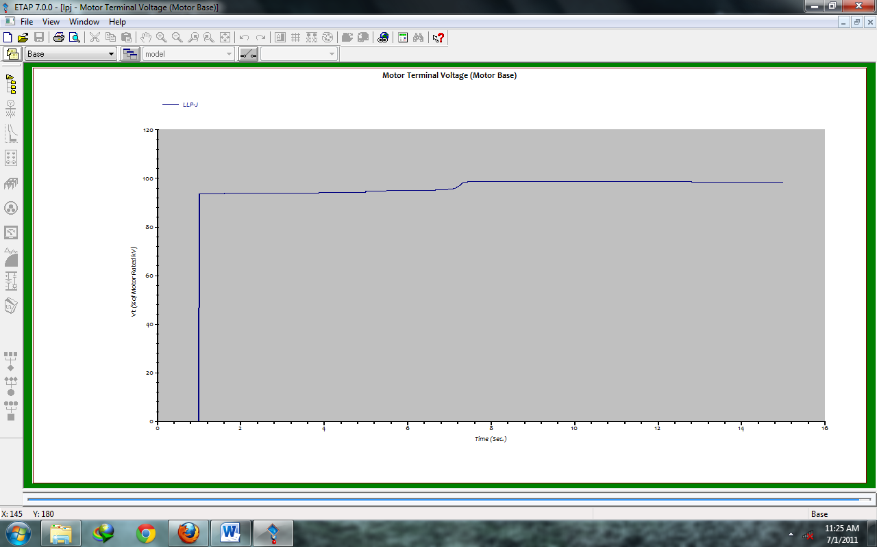Motor Terminal Voltage (% of motor rated volt) vs Time (sec)

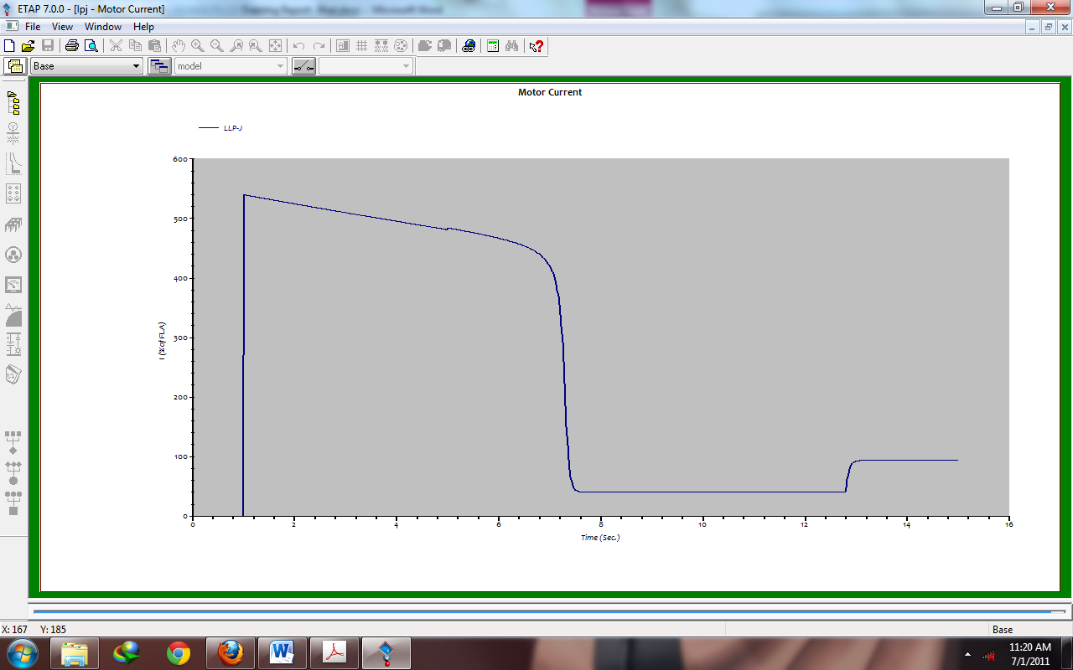Motor Current (amp) vs Time (sec)

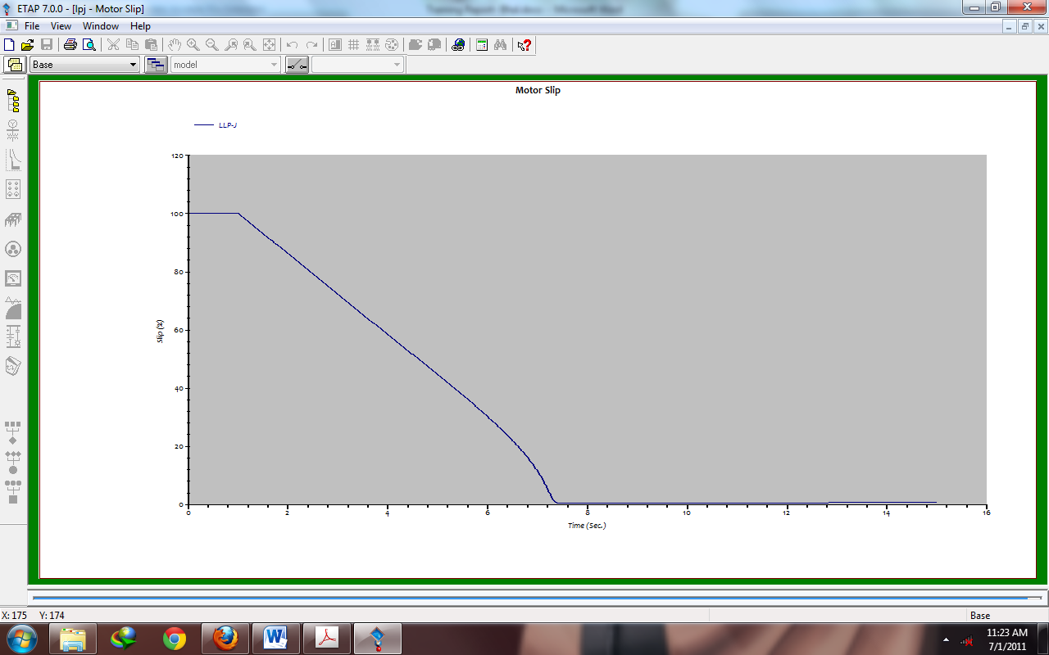Motor Slip vs Time(sec)

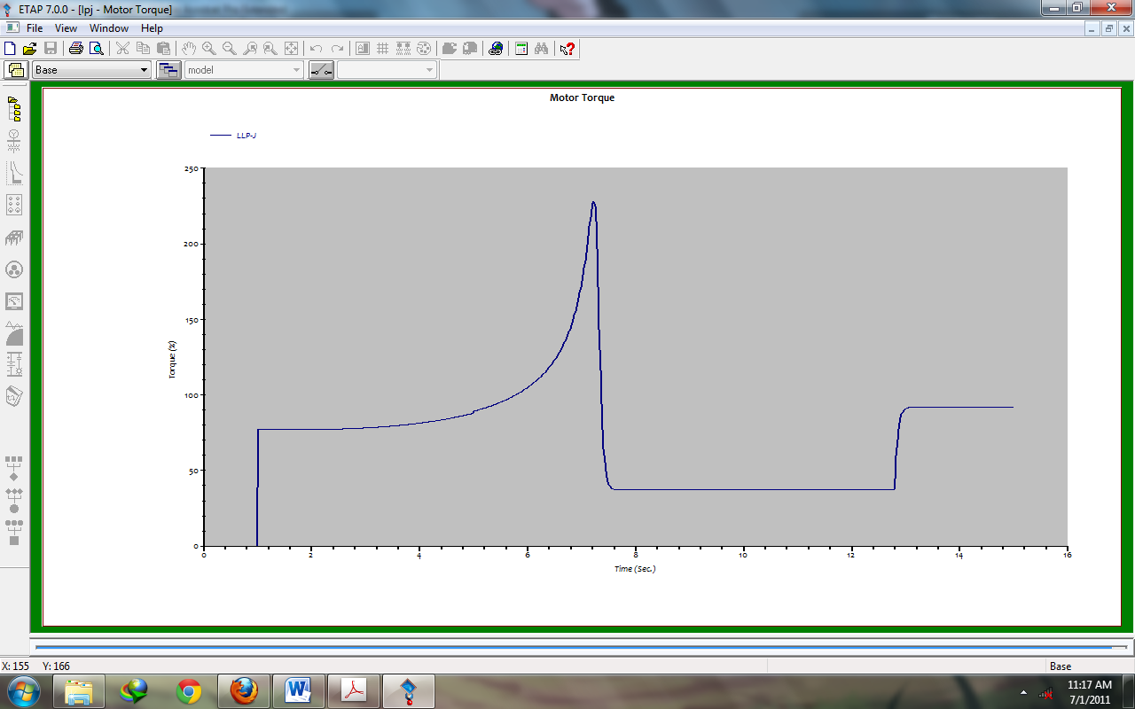Motor Torque vs Time(sec)

# Internship Activities

1. I got the opportunity to visit 100 KV switchyard, which was novel experience for me. I understood how power is supplied to different substations present in nearby districts, villages and other factories.
2. I utilize most of the time in UTILITIES which provides basic requirements for its nearby plants like low pressure air, compressed air, chilled water, cool water etc.
3. I also learned the applications of inverters and important role of UPS in the power setup inside factory.
4. I got the opportunity to examine various make and models of fuses, circuit breakers, current transformers. This helped me to get better understanding of these devices.
5. Apart I observed many precautionary measures taken during working on the high voltage lines as there is no space for mistakes to occur.
6. I understand the difference between synchronous motor and asynchronous motor. For asynchronous motors inverters were deploy which can provide any voltage between 0-400V and frequency between 0-400Hz.
7. I learned the importance of uninterruptable supply. As being a polyester manufacturing unit, even a small break in power caused the thread to break and thus would decrease the quality of production.  
   For this reason CPP, DG’s and UPS were employed.
8. Learned the importance of capacitor and synchronous motor (at leading power factor) for maintaining the power factor close to unity.
9. Took a look at motors operating in the industry to know the scale on which work in done.
10. Realised the importance of VFD’s in present industries as its popularity is increasing day by day although of its high initial cost. Majority of AC drivers were on VFD’s.

# Conclusions

1. Internship at RIL, Patalganga helped me to develop a better understanding of industrial application and various electrical machines.
2. It helped me to relate my theoretical concepts with practical applications thus establishing a critical link in between.
3. I also understood working principles in a large scale industry.
4. I also saw latest electrical instruments used in the industry and understood their applications.
5. This internship showed me a view of professional life of the engineers working, which will help me to direct myself in better way.
6. The safety standards and maintenance practices adopted by RIL have guided me for disciplined approach in industry.
7. Finally I want to thank from depth of my heart to **K.N Rao** & **all engineers at Utilities** for their continuous support and co-operation during whole course of my internship. This experience couldn’t have been pleasant without them.

# References

1. ETAP website <http://www.etap.com>.
2. Reliance Industries Ltd. Intranet portal.
3. Reliance Industries Ltd. Training Manuals.
4. Skm, Etap, & Edsa Power System Analysis Tutorials, By Stephen Philip Tubbs, 2009.
5. Help Guide of ETAP.
6. Power System Analysis, By Grainger, Tata McGraw-Hill Education, 2003.

# **Appendices**

## Appendix A

Electrical Transient Analyzer Program (ETAP)

Operation Technology, Inc. (OTI) is a full spectrum analytical engineering firm specializing in the planning, design, analysis, operation, training, and computer simulation of power systems. OTI is the proud developer of ETAP, the most comprehensive power system enterprise solution. With more than 50,000 licenses in over 100 countries, ETAP serves the power system needs from generation to utilization power system analysis and design software.

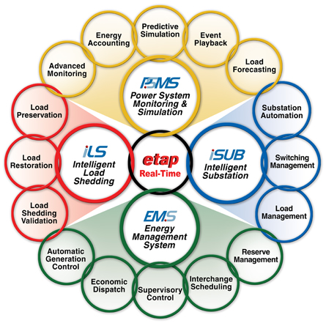

ETAP is the only power system analysis software approved for use in nuclear / high-impact facilities



**Features:**

• Advanced monitoring, simulation, & control

• Predict system response to operator actions

• Fast, optimal, & intelligent load shedding & restoration

• System optimization & automation

• Demand-Side Management

• Intelligent one-line diagrams

• Multi-dimensional database

• Time domain event playback with simulation capability

• Integrated alarm, warning, & acknowledgement

• Client-server configuration

• Built-in redundancy & automatic fail over

Power System Monitoring & Simulation (PSMS) is at the heart of the ETAP Real-Time management application. PSMS is the smart choice for both large and small electrical utility systems, generation plants, industrial sites, manufacturing facilities, and off-shore oil platforms. PSMS can determine the appropriate system response to a variety of changes and disturbances by using electrical and physical parameters, loading and generation levels, network topology, and control logics. In addition, PSMS can determine the source of potential problems and advise corrective actions to avoid interruptions.

Features of PSMS:

• Multi-console with multi-screen monitoring

• Graphical monitoring via ETAP one-line diagram

• Visual monitoring via Man-Machine Interface (MMI)

• Alarm annunciation with graphical interface

• Alert of equipment out-of-range violations

• Monitoring of electrical & non-electrical parameters

• Pseudo measurements (override measured data)

• OPC interface layer

• User-access levels

• Continuous real-time monitoring

• On-demand data retrieval

• Data reconciliation & consistency check

• Bad data detection & correction

• Alarm management & processing

• Energy cost monitoring & accounting

• Real-time load forecasting & trending.

## Appendix B

Schema 2 Report:

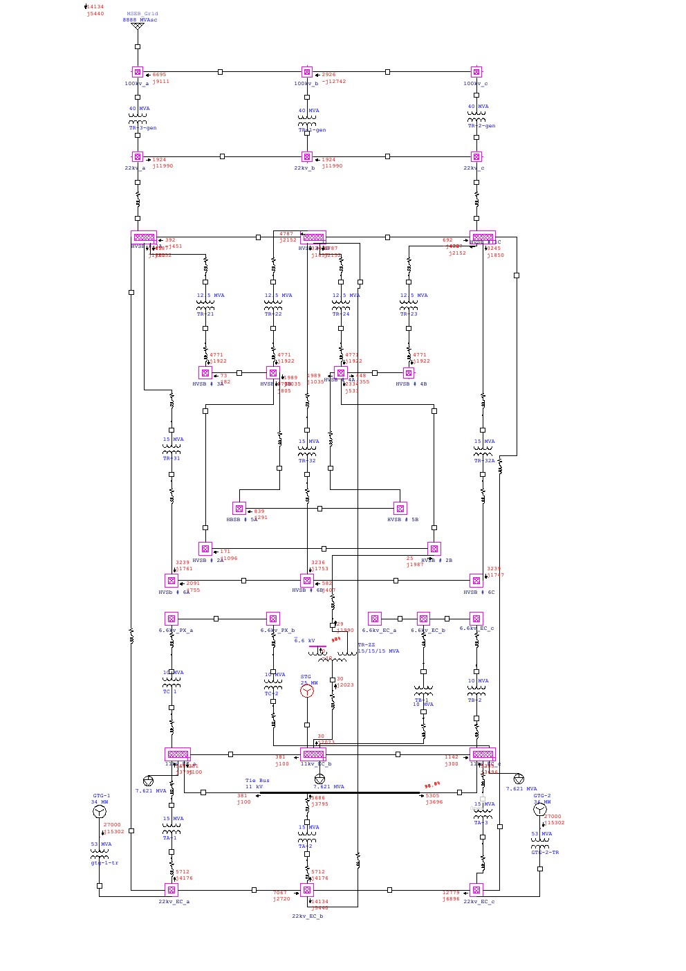

Schema 3 Report:

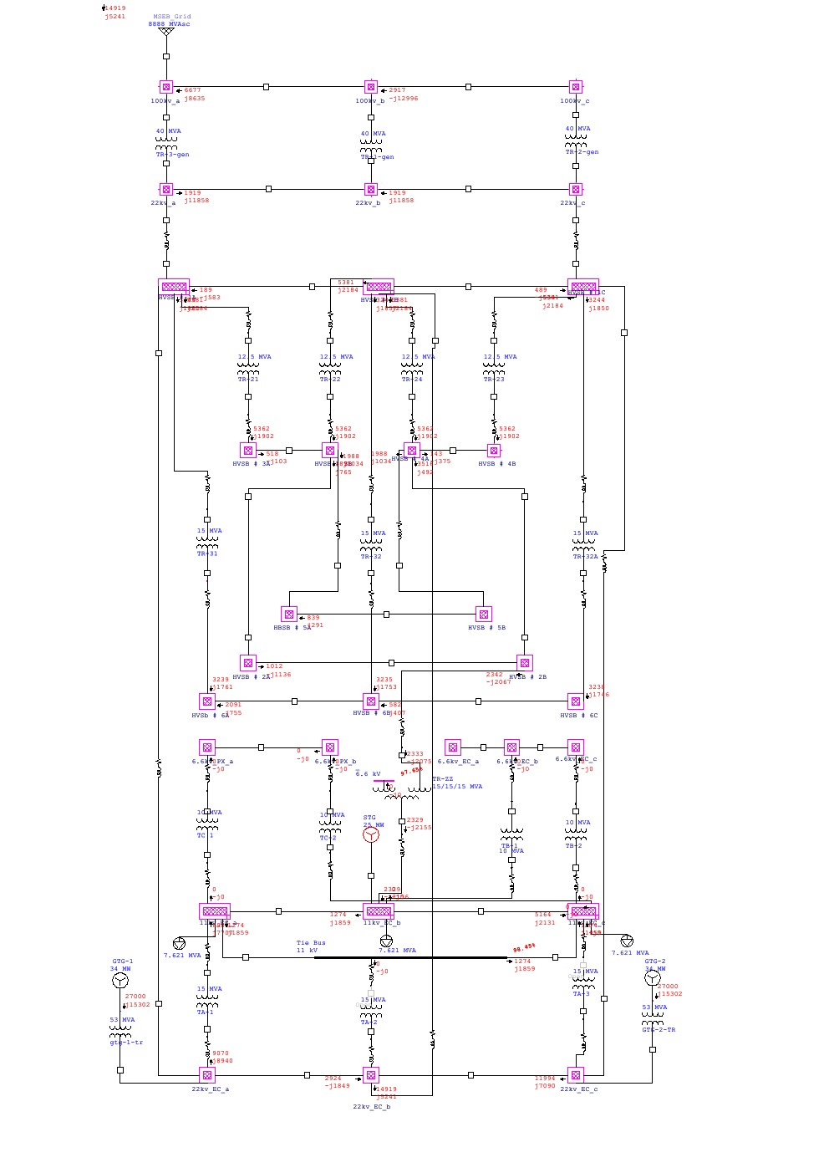

Schema 4 Report:

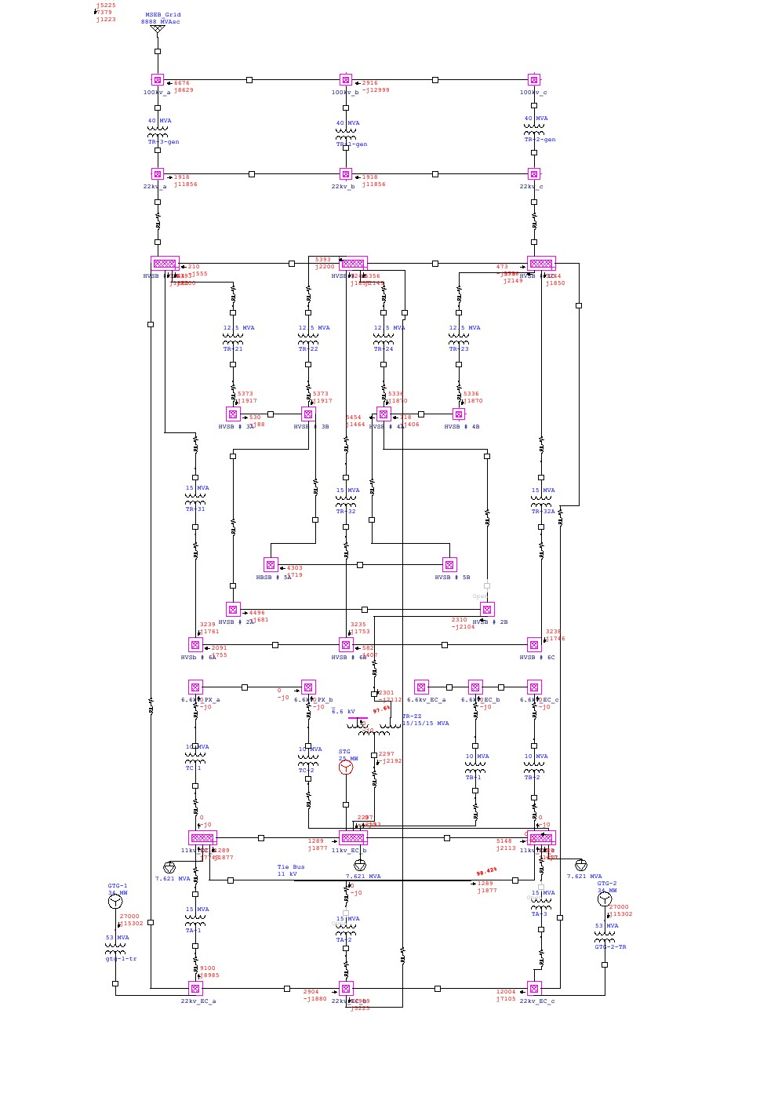

Schema 5 Report:

